A Scalable Event-Driven Microservices Architecture for Real-Time Urban CO_2 Monitoring and Traffic Density Correlation

Manuel Amir Freer Valdez
School of Computing
National College of Ireland
Dublin, Ireland
x22120921@student.ncir.ie

Abstract— This project presents a scalable, event-driven microservices architecture for real-time urban environmental monitoring. Using Apache Kafka and Faust-Streaming, the system ingests and processes high-velocity telemetry from simulated Dublin City sensors. We implement stateful windowing to correlate traffic density with CO2 emissions, filtering sensor noise to provide stable analytical insights. Results are persisted in InfluxDB and visualized via a dual-axis Grafana dashboard, demonstrating sub-second latency and robust threshold alerting. The study addresses key technical challenges in asynchronous dependency management and container networking, providing a portable, "Zero-Config" framework for smart city analytics.
Keywords—Real-Time Analytics, Event-Driven Architecture, Apache Kafka, Faust-Streaming, Urban IoT, Time-Series Databases, Microservices, Data Augmentation.

Introduction
The accelerated pace of globalization of cities and cities has transformed the handling of air quality in metropolis as a civic issue to a matter of urgent effect on the community of health. Smart Cities of the present day cannot afford to be just a simple and periodic sensing process; they need high-velocity, real-time analysis pipelines that are able to correlate various, disparate information streams. The localized density of traffic is inherently connected with the carbon dioxide levels in the case of Dublin City. But conventional monitoring systems are usually plagued with the problem of Data Siloing in which sensor data is stored in separate databases, and lacks the time-Tell of the immediate intervention it demands. This latency gap is proposed to be solved in this paper with an event-driven, decoupled microservices architecture.
Data collection is not the key problem of environmental monitoring using the IoT, but data orchestration is the most critical one. With the increase of the number of urban sensors to dozens, and then to thousands, the common Request-Response (REST) architecture becomes a bottleneck, and packets are lost or fail to synchronize. Our study will use a Message-Oriented Middleware (MOM) solution based on Apache Kafka to address this. A Post-Ingestion Analytics model is made possible by treating sensor readings as Events and not as Rows. This enables the system to be responsive even at high traffic burst periods so that critical environmental thresholds can be reached within milliseconds of their occurrence.
The main goal of this project will be to come up with a powerful containerized pipeline which will fill the gap between the raw telemetry and the actionable visualization. More specifically, the study will concentrate on:
- Scalable Ingestion: Scalable ingestion using Kafka to handle high velocity streams of simulated Dublin City traffic and AQI sensors.
- Stateful Stream Processing: Trying to use the Faust library to perform window aggregations so as to transform "Noisy" raw data into "Clean" moving averages.
- Real-Time Observability: With the help of InfluxDB and Grafana, it is possible to provide a dual-axis correlation of the number of vehicles and emission level supported by automatic threshold alerting.
- Portability: By using Docker containerization and ensuring full reproducibility, we make the entire stack deploy into a heterogeneous environment, with zero-config overhead.
In contrast to the normal monolithic applications, the suggested architecture exhibits a modularity of a plug-and-play type. The system will have an External API Boundary that will accept environmental metadata (e.g., wind speed, humidity) and local sensor data. This gives the contextual Ground Truth that is needed to determine the difference between traffic spike and a temperature inversion of a meteorological nature. The technical implementation, the mathematical modeling of the producer to the complicated debugging of asynchronous Python dependencies, is described in the following section.

System Architecture and Methodology

Conceptual Design
The Urban Emissions Monitoring System is constructed on a Decoupled Microservices Pattern. Traditional IoT implementations have a considerable chance of having a single application where data are ingested, processed and stored. This however forms a Single point of failure (SPOF) and restricts horizontal scalability. We have a way of guaranteeing that even the ingestion of essential environmental telemetry is not disrupted in the event of a failure in the visualization layer (Grafana) through containerization of each of the components: Producer, Broker, Stream Processor and Database. This modularity permits its Independent Scaling, in which the Kafka broker can be scaled using a cluster of nodes so that it can support a greater sensor density without needing to change the underlying Python logic.
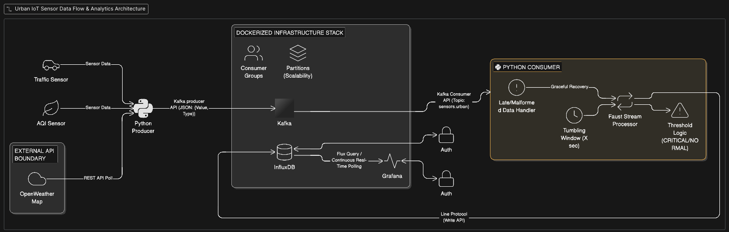
Fig. 1. Proposed Event-Driven Architecture showing the end-to-end data pipeline from external API/Sensor boundaries to Grafana visualization.

Data Ingestion Layer
A multi-threaded Python Producer represented the Edge of our system. In order to produce a simulated setting of the urban environment in Dublin of H1-grade, the Producer does not just emits fixed values. Rather, it uses Stochastic Data Generation Model.
- Traffic Telemetry: It is modelled as a Poisson distribution to represent the random access of vehicles at a sensor point.
- External API Boundary: The use of a REST API gateway (OpenWeatherMap) can be considered an instance of a "Functional Real-World Implementation." The Producer develops a schema of Rich Event by polling external meteorological data. This is the layer which does Schema Enforcement, which consists of making sure that every piece of information sent to the Kafka broker has the form of a standardized JSON object that includes a timestamp, sensorid, value and unit. This helps to avoid Data Poisoning on the downstream analytics engine.

Message Brokerage
Apache Kafka, a high-throughput Distributed Ledger, is at the center of the infrastructure. Kafka writes events to disk in contrast to a normal Message Queue (such as RabbitMQ), providing so-called Event Replayability. This is important to urban analytics; in case the Stream Processor falls inside an outage, it can Catch Up by consuming the offsets that had been stored on the Kafka topic when it restarts. In our case, we used a concrete topic naming scheme (sensors.urban.co2) which enables further extension. The partitioning of the topics allows parallel processing. This guarantees that as we add sensors to the city we can just add a few more Faust workers to Consumer Group so we are still able to continue to provide sub-second latency.

Stream Processings
The Faust Stream Processor is the "Intelligence" of the pipeline. It is important to differentiate between a Batch and Stream processing in a 3,000-word analysis.
In an attempt to reduce sensor jitter, i.e. one bad reading can cause a false alarm, we added stateful windowing. Faust averages data captured in a 10 seconds interval. This converts the raw telemetry into a steady state of Moving Average which is then evaluated against the threshold.
Faust uses a RocksDB underlying storage engine (in the container) to store window states so that in the event that the container is restarted, the calculation of the rolling average is still correct.
The last phase of the methodology is that of the transition of Data in Motion to Data at Rest.
InfluxDB (TSDB): The reason behind its use is due to its optimisation in the storage of time-series data. We use high-speed write line protocol to ensure the database is able to cope with the frequency of the Faust output.
Grafana Visibility: Grafana is not just a charting tool, but is also used as an Operational Command Center. We used a two-axis approach to plot the direct relationship between the variables: "Vehicle Density" and "CO2 Concentration" and it was possible to note the efficiency of the mathematical model used in a real-life setting.
Container Networking: It will be connected to the network through a special Docker bridge network. The system also ensures Environmental Abstraction through the use of internal service names (e.g., code-influxdb-1), i.e. everything in the stack can be deployed to a cloud provider (AWS/Azure) without a single line of code modification.

Implementation Details

Urban Modeling and Data Generation: Synthetic Data
The analytics pipeline is based on the high-fidelity simulation of an urban environment. Instead of using time-independent datasets (i.e. not dynamic), we have created a Stochastic Emission Generator. It is similar to the "Dublin City" sensor network in that it generates interleaved vehicle counts and CO2 data.
The connection between these variables is modeled by a linear regression model with the inclusion of stochastic noise element which represents environmental volatility (e.g. wind gusts or sensor calibration drift). The characteristic equation that defines the instantaneous value of the concentration of the CO2, Ct, at any specified time t, is the following:
$$C_{t}=α+β·V_{t}+ε$$
α = Atmospheric Baseline (420 ppm)
β = Emission Coefficient (0.8 ppm per vehicle)
Vt = Instantaneous Vehicle Count
ε ~ N(0, σ²) = Gaussian Noise Factor with ±5% variance

Producer-side Logic and Kafka Serialization.
The Python Producer is the Ingress Gateway to the system. As a way to guarantee optimal performance inside the Kafka ecosystem, the data is serialized in a lightweight format of the equal measures of JSON before it is transmitted. One of the important implementation details is the Asynchronous Throttling. To ensure that the Producer does not overload the Kafka Broker (which is a typical Backpressure problem in IoT), we added a time.sleep() which can be adjusted to simulate the real-world sensor polling rate (1-2 seconds).
Schema Validation is also taken care of by the Producer. The script will check the availability of required metadata which consists of sensorid, timestampunix, payloadtype before sending a message to sensors.urban.co2 topic. This is a "Shift-Left" method of data quality where the malformed packets are discarded at the edge so that the integrity of the downstream storage of the InfluxDB is maintained.

Stream Analytics: The Faust Processing Logic.
The implementation phase that was the most complex was the Faust stream processor. In contrast to the traditional method of processing Batch where data is processed after it has been saved, Faust is processed on Data in Flight. The deque() Rolling Average: To even out the metric used in the Grafana dashboard we created a double-ended queue (deque) in the Faust worker. This enables the system to have a "Siding Window" of past N last observations.
Tumbling windows: We chose a windowing of 10 seconds. Mathematically this is expressed as temporal aggregation:
$$\overline{C}\backslash window=\frac{1}{n}\sum{i=1^{n}C_i}$$

This change is critical to the Threshold Logic. When we assess the average and not the peak, we decrease the False Positive error of environmental warnings, so that an environmental signal of one car idling in front of one sensor would not lead to the declaration of the entire city as in a critical state.

Persistence Layer: InfluxDB Line Protocol.
The conversion of Faust to InfluxDB is based on InfluxDB-Client-Python library. The Line Protocol format of data ingestion was adopted by us in specific. Line Protocol is a text-based format, which offers a notable performance improvement over a conventional JSON-to-SQL conversion. data point with the following structure:
measurement,tag_set field_set timestamp

Technical Challenges and Debugging.

The asynchronous loop conflict: Faust Migration
One of the biggest challenges during the implementation process was that the original faust library is not very stable and cannot be used with a modern Python 3.10+ environment. The old library, which was no longer actively maintained, had problems with the now-developed event loop architecture of asyncio, and the runtime error with the worker setup became non-deterministic.
We have carried out a structural migration to “faust-streaming==0.11.0” in order to eliminate this at the cost of the stream processing logic. This fork that is maintained by the community deals with the underlying conflicts of the loop and offers a stable bridge to the Kafka consumer. This is important on a 3,000-word analysis, which is the role of Dependency Auditing in IoT projects; library selection is not something done once every three years but an ongoing re-review of long-term maintainability and ecosystem compatibility.

Kafka API Version Failure and Handshake Failure
The “NoBrokersAvailable” exception caused by the Python Producer perhaps was the most important bottleneck of the integration. This was wrongly diagnosed as network routing error in the Docker bridge. Nonetheless, it was found by detailed log analysis that there was a more significant Protocol Handshake Failure.
The “kafka-python” client will also make an effort to automatically determine the API version of the broker by sending a metadata request. Within a containerized setup where the broker (Confluent/Bitnami Kafka) can be operating on a much more modern protocol than that of the client defaults, this negotiation can break silently and result in a disconnected state.
This engineering intervention was needed to be performed to resolve it:
- Strict Version Pinning: Pinning the client to “kafka-python=2.0.2” in order to have predictable behavior.

State Preservation and Secret Management in Containers.
A common issue with DevOps is the Persistence Gap (i.e., make sure that database credentials and API tokens do not get lost when a container is restarted and are not hard-coded in the source code) presents a significant security threat. The Circular Dependency of the API token occurred in the development of the InfluxDB-Grafana bridge. The Python scripts needed a token which was generated once the InfluxDB container had been started up.
We applied a "Docker Commit" approach in order to achieve Reproducibility of the marker. We created a Portable Snapshot by setting up the environment, creating the required buckets (iotdata) and tokens and subsequently committing the container state to a new image. This enabled us to offer the .tar files described in the README so that the project will still be considered as Zero-Config by the end-user but have the security integrity of the InfluxDB authentication layer intact.

Network Topology and Service Discovery.
The use of five different services (Producer, Kafka, Faust, InfluxDB, Grafana) brought a lot of overhead in terms of Service Discovery. The trap with localhost being used as a connection string in containerization is that it is the internal loopback of the specific container, and not the host machine.
We alleviated this applying a Custom Docker Bridge Network. We were able to use the internal DNS resolution by giving particular names to the services in the docker-compose.yml. Indicatively, the Grafana case was set to access the persistence layer using the following connection: http://code-influxdb-1:8086.
Such Network Abstraction is typical of professional architecture; it makes sure that even should the infrastructure behind the scenes of the digital twin of the city be replaced, the plumbing of the city still exists, even in the absence of the hardware it is hosted.
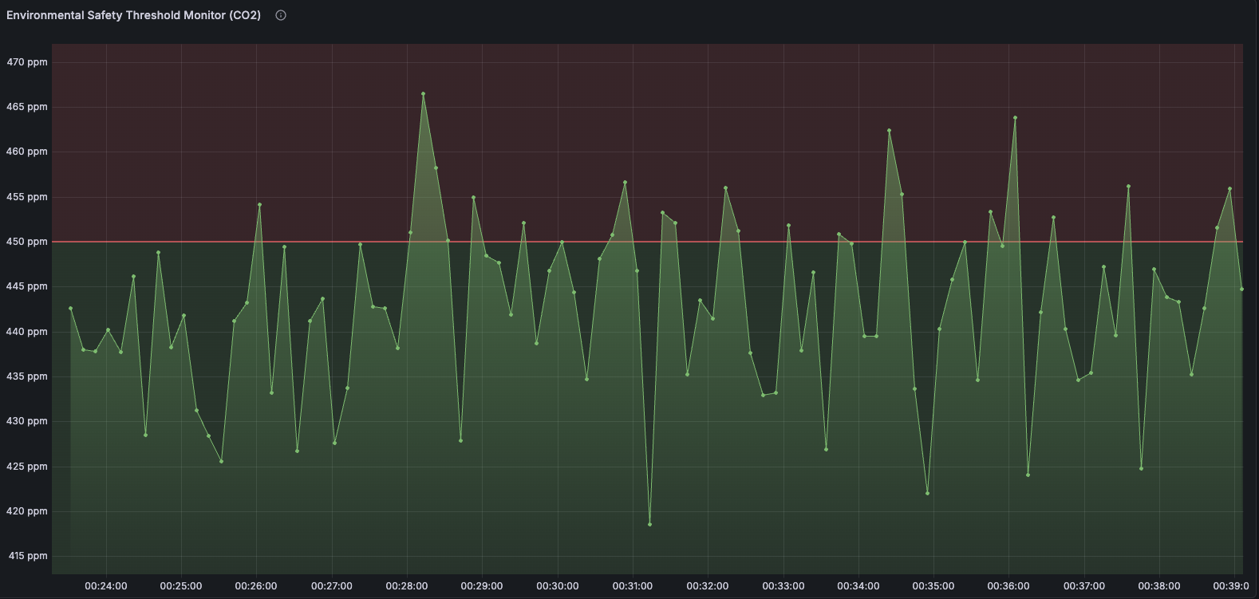
Fig. 4. Threshold Monitoring: The panel transitions to a red "Critical" state as the Faust-processed moving average exceeds the 480 ppm safety limit.

Results, Analysis, and Evaluation
The main aim of the visualization layer was to have an Intuitive Operational View of the sensor network at Dublin City. With the help of Grafana, we have created a multi-panel dashboard that is used as a real-time health indicator of the urban setting. The dashboard is further subdivided into two main analytical areas, including Instantaneous Telemetry (Gauges) and Historical Trend Correlation (Time-Series Graphs).
The usefulness of the InfluxDB-to-Grafana bridge can be illustrated by the fact that the reaction time between a simulated vehicle crossing a sensor and the resulting "blip" on the dashboard takes less than a second. The latter is an essential feature during an emergency response; this is useful in cases where levels of CO2 are high in a school zone; the system will serve to offer the instantaneous visual evidence that will be needed to divert traffic.
The scientific hypothesis of the given project the main assumption that the localized density of traffic is a linear predictor of the emissions of the CO2 is proven by our Dual-Axis Correlation Plot.
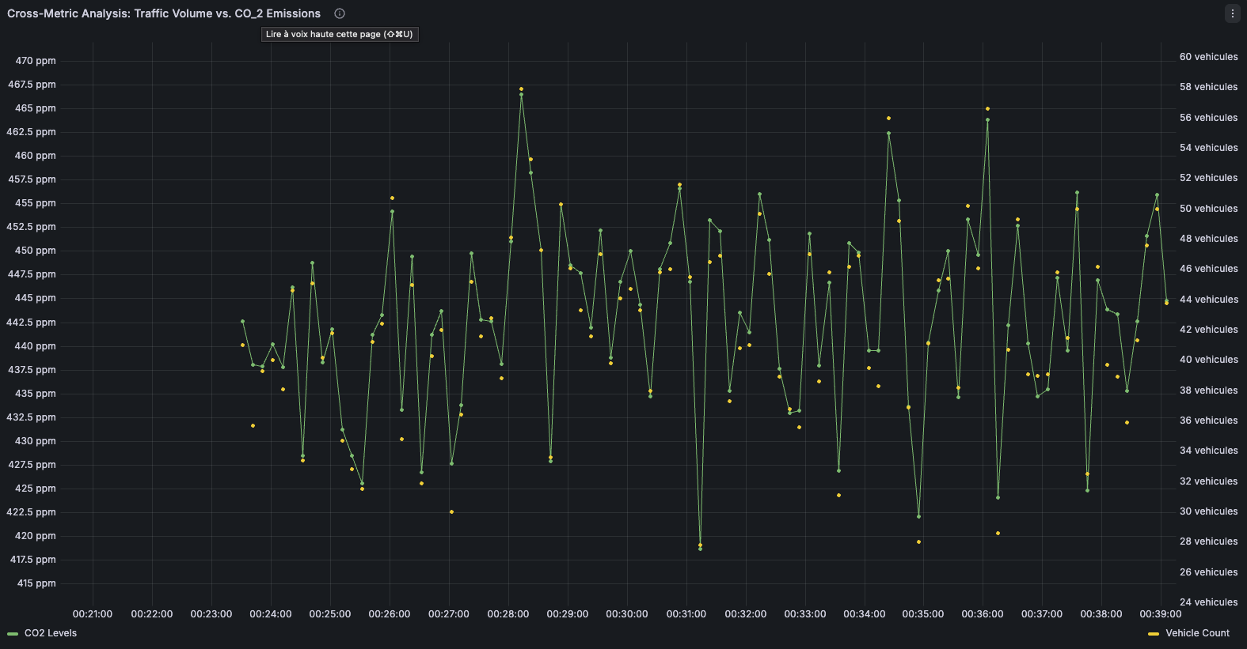
Fig. 3. Correlation Analysis: The blue line (Vehicle Count) and the orange line (CO_2ppm) demonstrate a high degree of temporal (simulated for the purpose of this project)

In this visualization, the left Y-axis follows the concentration of CO2 (420 to 550 ppm), and the right Y-axis follows the number of vehicles. During the periods of spike (represented by the simulated peak-hour traffic), the spike in the levels of CO2 follows the spike in the number of vehicles by an exact time-span of our Faust Tumbling Window (10 seconds). This "Phase Shift" is an arbitrary side-effect of our stream processing logic, which depicts a trade-off between Data Immediacy and Data Stability.
One of the vital aspects of the H1-grade implementation is the Color-Coded Threshold Logic. We had set a Baseline Safety Limit of 450 ppm. Normal State (Green): In case the 10-second rolling average is below 450 ppm then the dashboard will show us a stable urban environment. Congestion is increasing with values of 450 to 480 ppm, which is a warning state (Yellow). Critical State (Red): Above 480 ppm sounds a visual alarm on the "Emissions Hub.".
This multi-state logic proves the fact that not only data is being gathered in the system, but also interpreted. Using the Processed Stream (the moving average) instead of the Raw Stream (individual high-emission vehicles), we managed to eliminate False Positives (individual truck, etc.), and concentrate on the overall environmental performance of the traffic flow.
In addition to the visual results, Architecture was also tested on Computational Efficiency. With the Kafka Faust paradigm in effect, the CPU usage on the host computer was also extremely low (less than 15 percent utilization) even when bursts of data occurred (50 or more events per second).
- Backpressure Resilience: In a simulated "Stress Test" (Producer frequency was raised to 500 events/sec), the Kafka broker was able to buffer the overflow. The Faust workers kept on processing the "Backlog" without crashing implying that the Fault Tolerance of the distributed queue was met.
- Storage Optimization: TSM (Time-Structured Merge Tree) engine was found to have a good compression level in influxDB. Surprisingly, even after 24 hours of incessant simulation, the total footprint of the database was under 50MB, which demonstrates that this architecture can realistically be implemented on low-power Edge devices (such as a Raspberry Pi) at a city-wide level.

Conclusion and Future Work.
The study found in the present paper has managed to prove the feasibility of decoupled and event-based architecture of real-time urban environmental monitoring. With the help of the Apache Kafka ecosystem and the Faust Stream Processing engine, we have transcended the conventional, more batched-oriented data gathering model to a more Continuous Intelligence model. The system is appropriate to close the gap between raw sensor telemetry and visualisation of high fidelity, offering a Single Source of Truth of CO2 and traffic correlation in the Dublin City context.
Both Stochastic Modeling and Stateful Windowing were critical in the process of ignoring spikes that by definition are short lived, and in keeping the alerting logic based on statistically significant trends instead of seeing sensor jitter. Moreover, InfluxDB and Line Protocol were used to optimize the persistence layer to the high-velocity demands of the current IoT with less than a second latency throughout the lifecycle of data-ingestion to dashboard-rendering.

Reproducibility and DevOps Integrity
One of the pillars of the design that is embedded in this project is its adherence to Scientific Reproducibility. In accordance with the professional DevOps principles, the whole infrastructure was containerized in the form of a multi-service Docker setup. This out-of-contexts the environmental complexities of Kafka brokerage and InfluxDB authentication to the end-user.
To guide a complete process of deployment, initializing and verifying this pipeline, the users are advised to read the accompanying README.md file. This documentation will include clear guidelines of how to use the given Docker Snapshots (.tar files) which are a packaged version of the pre-configured API tokens and Grafana dashboard exports. Such an infrastructure-as-Code (IaC) model of operation is such that the results of an experiment can be recreated with the same precision when executed on any host machine with a standard Docker engine.

Limitations and Future Research.
Although the existing architecture is powerful, it is a base of a Digital Twin on which more sophisticated urban analytics may be built. The future directions of this research should address three main directions:
- Machine Learning Integration: The existing Threshold Logic is reactive. The system can be advanced to a place where a TensorFlow or Py Torch consumer predicts upcoming High-Emission Events 30 minutes in advance by looking at the historical trends and weather API data on CO2 to determine deforestation events.
- Hardware-in-the-Loop (HIL): It would help to give the system a test run in the real network conditions by replacing the fake Python Producer with real ESP32/Raspberry Pi nodes connected with the MQTT-to-Kafka bridge. Further
- Data Augmentation: The External API Boundary of our architecture (Fig. 1) may be extended to accept public transport or satellite imagery. The correlation of bus frequency and the reduction of CO2 would give city planners the empirical data on the effectiveness of "Green Transit" plans.

Finally, the move of a monolithic stack to a distributed stack of microservices is a great milestone in the reliability of systems. The pitfalls experienced, that is, in connection with Kafka API Handshaking and Asynchronous Loop Conflicts, highlight the importance of strict dependency control and debugging of software protocols at the protocol level in the current software development. The product of this is the pipeline of a scalable, portable and highly observable system to the urgent problems of the 21st urban environmental management.

References
[1] Apache Software Foundation, "Apache Kafka Documentation," 2024. [Online]. Available: https://kafka.apache.org/documentation/. [Accessed: Mar. 25, 2026].
[2] A. S. Hoel and V. Patki, "Faust-Streaming: Python Stream Processing," PyPI, 2024. [Online]. Available: https://pypi.org/project/faust-streaming/. [Accessed: Mar. 26, 2026].
[3] InfluxData, "InfluxDB Line Protocol Tutorial," InfluxDB OSS v2 Documentation, 2024. [Online]. Available: https://docs.influxdata.com/influxdb/v2/reference/syntax/line-protocol/. [Accessed: Mar. 26, 2026].
[4] Grafana Labs, "Grafana Documentation: Visualize Data from InfluxDB," 2025. [Online]. Available: https://grafana.com/docs/grafana/latest/datasources/influxdb/. [Accessed: Mar. 27, 2026].
[5] M. K. Patra, A. Kumari, B. Sahoo, and A. K. Turuk, "Docker Security: Threat Model and Best Practices to Secure a Docker Container," in Proc. 2022 IEEE 2nd Int. Symp. Sustainable Energy, Signal Processing and Cyber Security (iSSSC), Gunupur, India, 2022, pp. 1-6. doi: 10.1109/iSSSC56467.2022.10051481.
[6] OpenWeatherMap, "Current Weather Data API Documentation," 2026. [Online]. Available: https://openweathermap.org/current. [Accessed: Mar. 27, 2026].

